WEEK 1 ASSIGNMENT

Students should:
- Install all development tools
- Create one flutter app
- Submit screenshots and source code
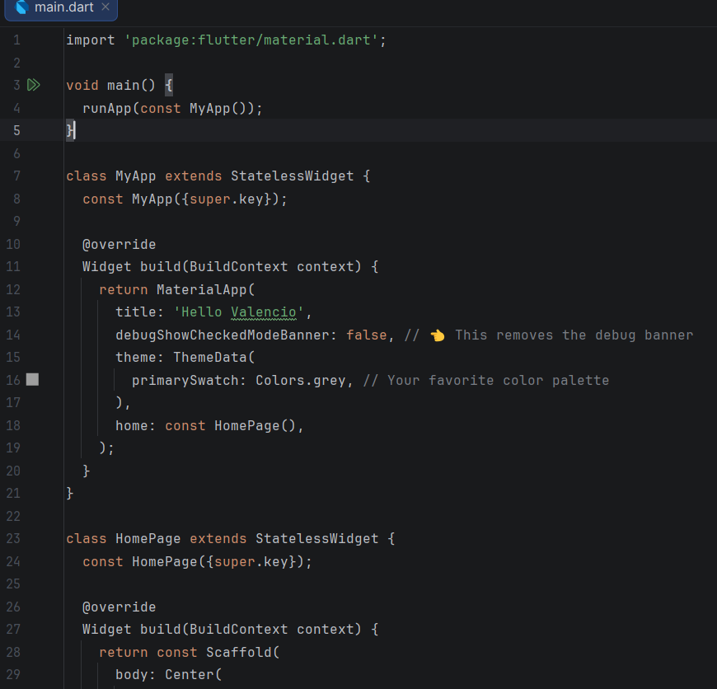
- Source Code

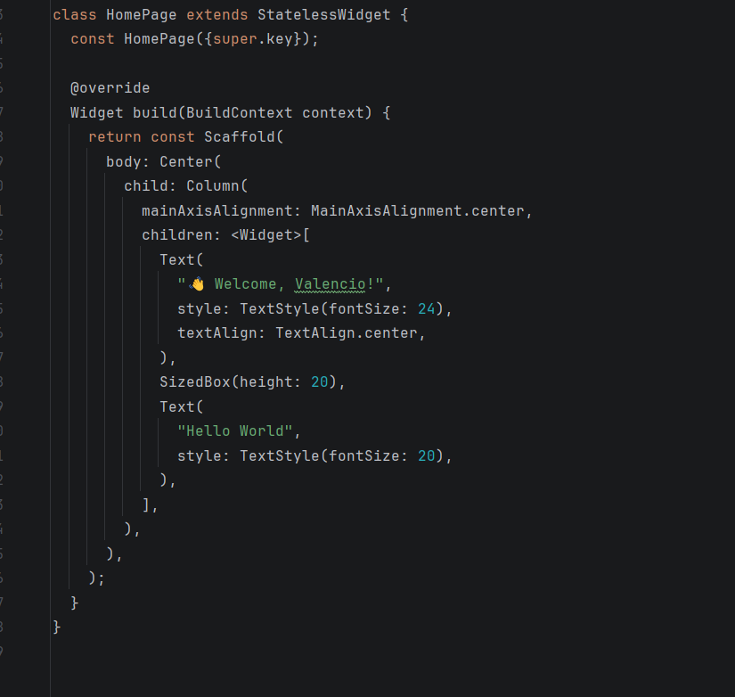
ii. The Page
